**BAMBOO JOB CONFIGURATION**



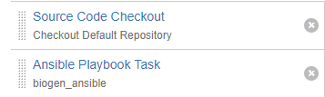

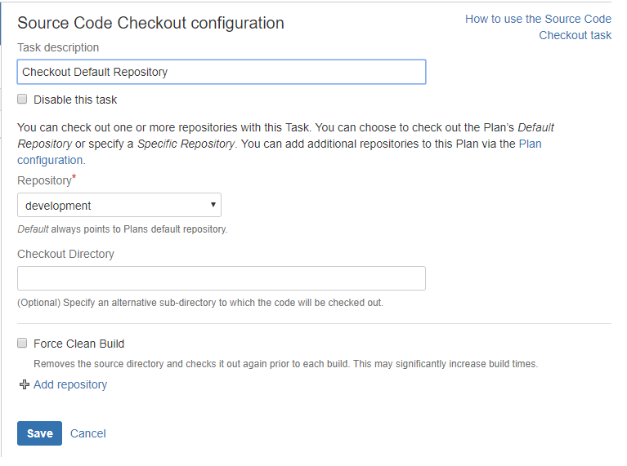

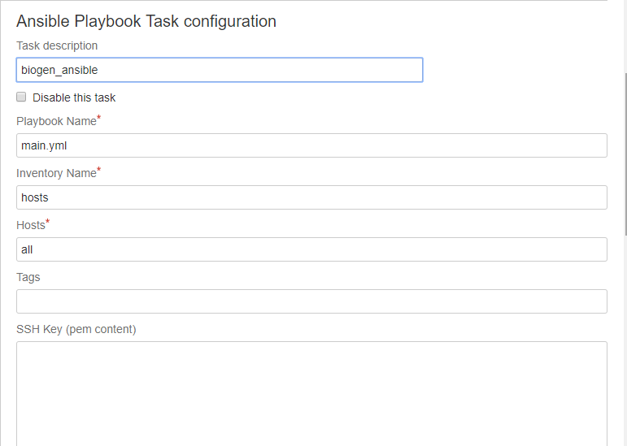



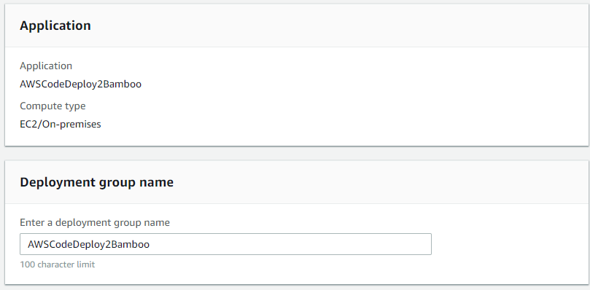

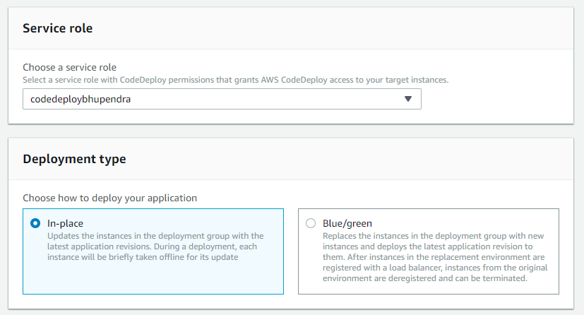

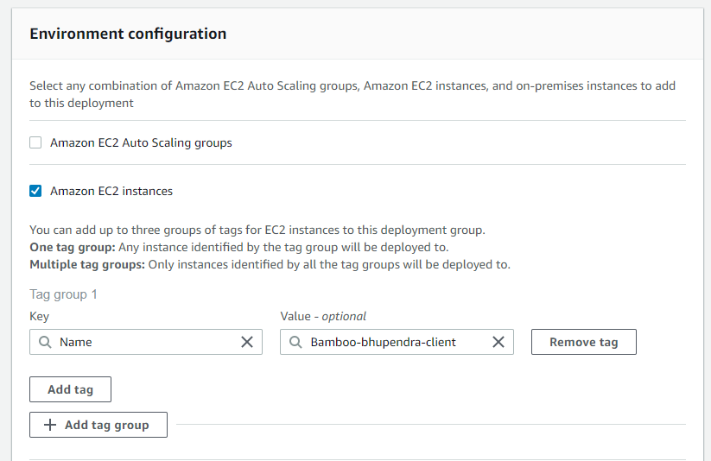

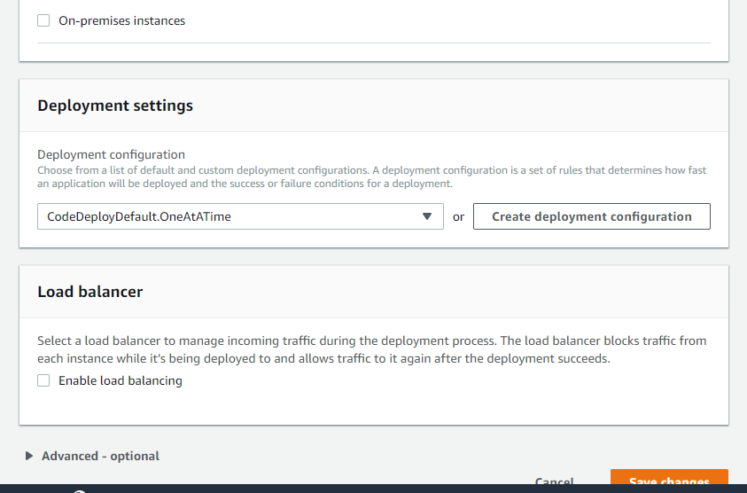

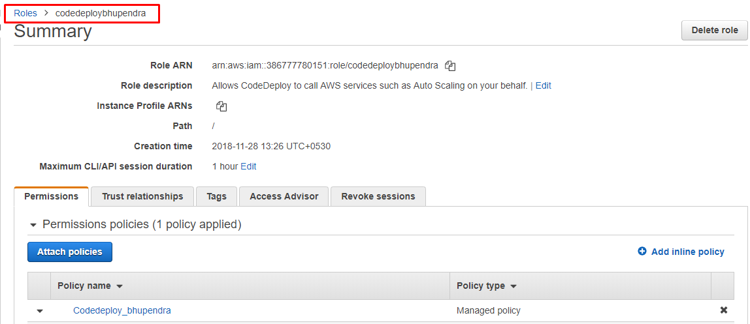

{

"Version": "2012-10-17",

"Statement": [

{

"Action": [

"autoscaling:PutLifecycleHook",

"autoscaling:DeleteLifecycleHook",

"autoscaling:RecordLifecycleActionHeartbeat",

"autoscaling:CompleteLifecycleAction",

"autoscaling:DescribeAutoscalingGroups",

"autoscaling:PutInstanceInStandby",

"autoscaling:PutInstanceInService",

"autoscaling:DescribeLifecycleHooks",

"ec2:Describe*"

],

"Effect": "Allow",

"Resource": "*"

}

]

}

EC2-Machine ROLE

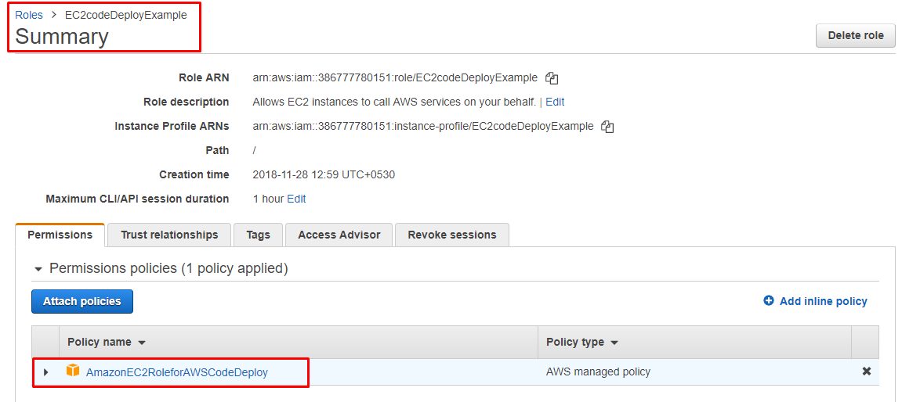



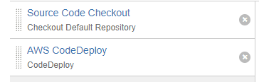

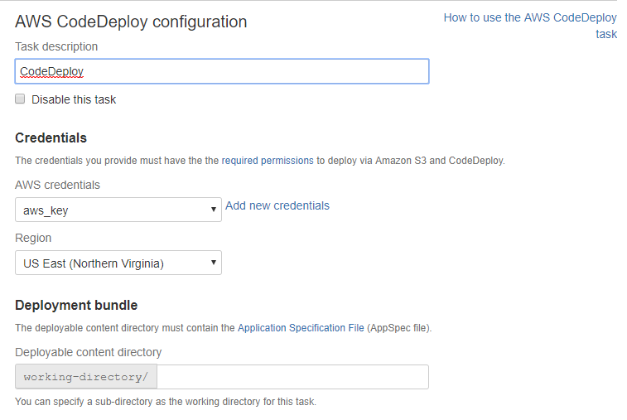

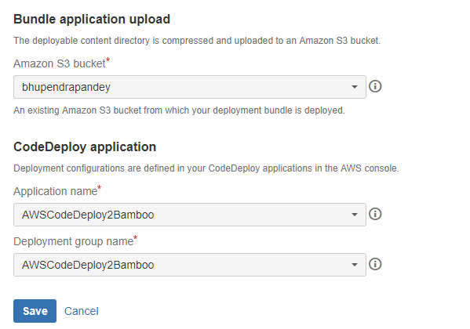

-----------------------------------------------------------



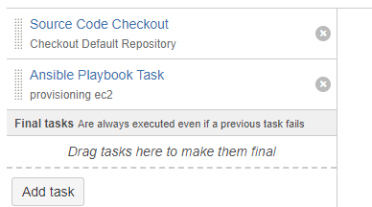

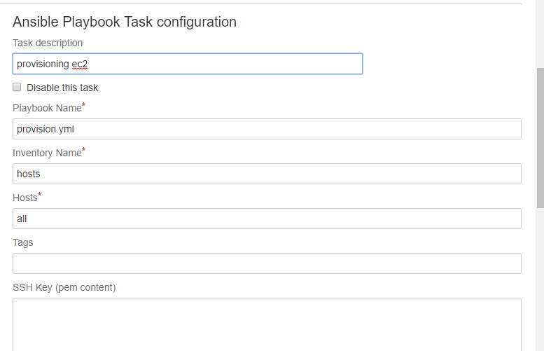

BITBUCKET repository files for Ansible playbook

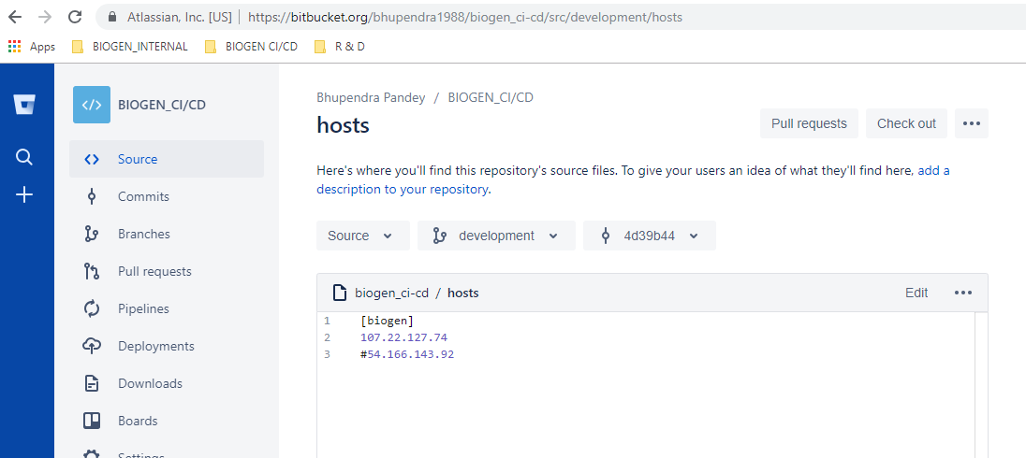

[biogen_ci-cd](https://bitbucket.org/bhupendra1988/biogen_ci-cd/src/development/)/**provision.yml**

---

*### provision AWS EC2 instance*

- hosts: all

*##connection: local*

gather_facts: **false**

*## user: centos*

*## become: yes*

tasks:

- name: Provision {{ ec2_count }} instances with tag {{ ec2_tag_Role }}

local_action:

module: ec2

key_name: bhupendra-N-Virginia-key

group_id: sg-039680786261690c0

instance_type: t2.micro

image: ami-04f734233df18b7cd

vpc_subnet_id: subnet-cba42ee6

region: us-east-1

assign_public_ip: yes

wait: **true**

count: 1

volumes:

- device_name: /dev/xvda

volume_type: gp2

volume_size: 8

delete_on_termination: **true**

[biogen_ci-cd](https://bitbucket.org/bhupendra1988/biogen_ci-cd/src/development/)/**terminate.yml**

---

*### Terminate AWS EC2 instance*

- hosts: all

gather_facts: **false**

tasks:

- name: Terminate instances that were previously launched

ec2:

state: 'absent'

instance_ids: i-03cefb84fce70c54b

region: us-east-1

[biogen_ci-cd](https://bitbucket.org/bhupendra1988/biogen_ci-cd/src/development/)/**start_ec2.yml**

---

*### Start AWS EC2 instance*

- hosts: all

gather_facts: **false**

tasks:

- name: start ec2

ec2:

state: 'running'

instance_ids: i-03cefb84fce70c54b

region: us-east-1

[biogen_ci-cd](https://bitbucket.org/bhupendra1988/biogen_ci-cd/src/development/)/**stop_ec2.yml**

---

*### Stop AWS EC2 instance*

- hosts: all

gather_facts: **false**

tasks:

- name: stop ec2

ec2:

state: 'stopped'

instance_ids: i-03cefb84fce70c54b

region: us-east-1

[biogen_ci-cd](https://bitbucket.org/bhupendra1988/biogen_ci-cd/src/development/)/**appspec.yml**

version: 0.0

os: linux

files:

- source: /

destination: /opt/tomcat/apache-tomcat-7.0.92/webapps

hooks:

BeforeInstall:

- location: scripts/install_dependencies.sh

timeout: 300

ApplicationStart:

- location: scripts/start_sessions.sh

timeout: 300